D.K.T.E. Society’s Textile and Engineering Institute, Ichalkaranji.

(An Autonomous Institute, Affiliated to Shivaji University, Kolhapur)

Department of Computer Science & Engineering

2018-19



**Software Requirements Specification (SRS) and Design Document**

On

Multiplayer Blade Showdown Game Using Augmented Reality

**Submitted By:**

1. Indolikar Prathmesh Sudhir 15CMPN13
2. Yadav Akash Chaitanya 17CTRCMPN72
3. Digraje Abhinandan Shrenik 15CMPN04
4. Nilkanth Dhanraj Umesh 15CMPN37
5. Nagare Mrunal Sandip 15CMPN36

Prof. P. M. Gavali Dr. D. V. Kodavade

Project Guide Head of Department

D.K.T.E. Society’s Textile and Engineering Institute, Ichalkaranji.

(An Autonomous Institute, Affiliated to Shivaji University, Kolhapur)

Department of Computer Science & Engineering

2018-19

**CERTIFICATE**

This is to certify that,

1. Prathmesh Sudhir Indolikar 15CMPN13
2. Akash Chaitanya Yadav 17CTRCMPN72
3. Abhinandan Shrenik Digraje 15CMPN04
4. Dhanraj Umesh Nilkanth 15CMPN37
5. Mrunal Sandip Nagare 15CMPN36

Have successfully completed the project SRS and Design work, entitled “**Multiplayer Battle showdown game using Augmented Reality**”. In partial fulfillment of B. E. Computer Science and Engineering Part I/ November 2018 examination. This is the record of their work carried out during academic year 2018- 19

Prof. P. M. Gavali Dr. D. V. Kodavade

Project Guide Head of Department

Prof. P. V. Kadole

Director External Examiner

INDEX

1. Introduction
2. Problem Description 4
3. Purpose 4
4. Problem Statement 4
5. Scope 4
6. Overall description
7. Project Perspective 5
8. Product Functions 5
9. Specific Requirements
10. External interfaces 6
11. Functional Requirements 6
12. Performance Requirements 6
13. Design constraints 7
14. Software System Attributes 7
15. Software Design Document
16. System architecture 9
17. Class diagram 10
18. Use-case diagram 11
19. Activity diagram 12
20. Data flow diagram 13
21. Sequence diagram 14
22. Collaboration diagram 15
23. Component diagram 16
24. Deployment diagram 17
25. References

References 18

# Introduction

## Problem Description, Purpose, Problem Statement

1. **Problem description:**

To develop a multiplayer interaction application using augmented reality which will take a marker-based recognition image using camera device and will provide virtual interaction between users. To implement a multi-user platform using augmented reality through an android application to provide a real time interaction experience.

1. **Purpose:**

The project proposes the use of the concept of Augmented Reality. It is an interactive experience of a real-world environment whereby the objects that reside in the real-world are "augmented" by computer-generated perceptual information.

1. **Problem Statement:**

To develop a multiplayer interaction application using augmented reality using camera device and will provide virtual interaction between users.

## Scope

1. The proposed work will use the Computer Vision technology to determine the surface on which the object will be deployed.
2. The proposed work will explore the multi-user network interaction dimension and will use it to connect the smartphones.
3. The proposed project will involve two user communication through the applications installed on their respective smartphones.

# Overall description

This section of the SRS should describe the general factors that affect the product and its requirements.

## Project perspective

The proposed project will be thoroughly based on the concept of Augmented Reality. It will emphasize on the multi- user interaction and will also support the multiple device communication to facilitate the proposed augmented experience. The proposed project will also be using Vuforia SDK which is essential to inhibit the object detection and recognition. It will provide the assistance of Computer Vision to determine the field of vision and deploy the target object in the subjective field.

The proposed project will also facilitate the gaming experience in the real life scenario. It will emphasize on the networking module. The proposed project will be based on the relative moment of the objects controlled by the respective users. It will detect the collusions between the objects and will determine the user whose object will be the winner of the module and also save the battle details in the repository.

## Product functions

1. The proposed work will have a login module using which the user will start the application.
2. The product will have the connection module to connect to multiple players using the implementation of multithreading.
3. The proposed work will collect the real time video based featured like the collateral damage to the imbibed objects from camera installed on the smartphone which has the application installed on it and track the communication features from the video. From the features extracted, if the results showed that one player has been defeated, the product will generate the output result and it will display the winner and store the logs in the database.
4. The product will collect the battle data and extract the necessary features through which it will use in the further battle in the form of machine learning based implementation.

# Specific requirements

Following are the software requirements to a level of detail sufficient to enable designers to design a system to satisfy those requirements, and testers to test that the system satisfies those requirements.

These requirements include at a minimum a description of every input (stimulus) into the system, every output (response) from the system, and all functions performed by the system in response to an input or in support of an output.

## External interfaces

1. The product will collect the real time video from camera installed on the steering wheel column and track the facial features from the video. From the features extracted, if the results showed that the driver is distracted, the product will generate an alarm and it will alert the driver from distraction.
2. From the video captured at real time, the system will extract the necessary features to detect the driver’s distraction and as output if the driver is distracted then the system will alert them using alarm.

## Functional Requirements

1. **Surface Detection using Mobile Smartphone Camera.**

The proposed work will use the mobile camera of any smartphone device and using the installed application on the device, it will detect the surface on which the object will be deployed. The proposed work will be using marker-less augmented reality concept.

1. **Network based Application Connection.**

The proposed work will comprise of interaction of multiple users. Thses users will require to connect their smartphone devices through the use of internet and the support modules provided in the application.

1. **Real-time multiple User interaction and Object collusion.**

The proposed work will include a user interaction module in which the users will interact using their respective objects in the real life scenario. The objects will be subjected to collusions which will determine the strength factor of the object.

## Performance requirements

1. To implement a system which will mot crash throughout its implementation. This will be facilitated by the exception handling mechanism.
2. To implement a system to detect the surface on which the object will be deployed my mean of identification.
3. To implement a system capable on running on all the android based smartphones.

## Design constraints

1. Quality of Camera will affect the accuracy of the system.
2. The low power processor can affect the accuracy of the system.
3. Poor network connection might be an issue in real-time interaction.

## Software system attributes

There are a number of attributes of software that can serve as requirements. It is important that required attributes be specified so that their achievement can be objectively verified.

### Reliability

The system will be able to process all work correctly and completely without being aborted. The data after each battle will be recorded and stored.

### Availability

System after connection is establishes will provide service without interruption and users will be able to interact with one another.

### Security

System should provide the user authentication and authorization at the time of execution of the proposed work so that the connection will not be interrupted

### Maintainability

The system will update with the collection of data at regular intervals.

### Portability

The system is available online hence it doesn’t require any server at the user side. The system is easily portable.

# Software Design Document

## Module Description:

Below mentioned are the various diagrams of the proposed work. It will include the various modules as per the distribution of the tasks in various phases. Following are the modules:

1. **Network Establishment Module**

The Network Establishment Module will be the entry point of the proposed work. It will provide the connection between the users in order to facilitate the communication between the objects thereafter in the module.

1. **Interaction Module**

The Interaction Module will facilitate the connection and actual interaction of the objects of the proposed work. It will provide the base for the objects for interaction and this will be supported using the network connection.

1. **Interaction Module**

The Object Module as the name suggests will be the repository of the proposed work. It will comprise of the objects developed for the proposed work. These objects will constitute the back end of the project.

1. **Storage Module**

The Storage Module as the name suggests will be the storage of the proposed work. It will store the objects developed for the proposed work. These objects along with the battle details will constitute the storage repository of the project.

1. **Result Module**

The Result Module as the name suggests will serve the result of the proposed work. It will comprise of scores of the individuals.

## Diagrams:

4.2.1. System Architecture:

Interaction

Module

Database

Object

Module

Network

Module

Storage Module

Sound (Machine Learning) Module

Result (Output) Module

Figure 4.2.1 : System Architecture

4.2.2. Class Diagram:

Figure 4.2.2: Class Diagram

+ create_acc()

+ add_ arena(A, B, C, D)

+ delete_ arena

+ add_blade()

+ delete_blade()

+ connect_user()

+ start_fight() ()

+ result_analysis()

User()

New_User()

Administrator

Login

+ username/id

+password

+ get_username()

+ get_password()

+ get_contactno()

+ get_birthdate()

4.2.3. Use Case Diagram:

Figure 4.2.3.: Use Case Diagram

4.2.4. Activity Diagram:

Figure 4.2.4. : Activity Diagram

Enter Username and password

Validate Password

Connect user()

battle user()

add / delete blade()

Add/ delete arena()

set blade power()

get Test Results

Logout

Exit game screen

Login

4.2.5. Data Flow Diagram:

Change in X, Y using Joystick

Place on screen

Player 2 health 0

Change Position

Player 2 health (non- zero)

Change Position

User

User

Change Position

Change Position

Player 2 health 0

Change in X, Y using Joystick

Player 2 health (non- zero)

Place on screen

Figure 4.2.5.: Data Flow Diagram

4.2.6. Sequence Diagram:

Display the results to the user and save the logs to database

Start battle

Connect to users

Invalid Login

Verify id and password

Connection

Figure 4.2.6.: Sequence Diagram

get data from database

Tap to login Option

Run the application

Network

Result

Battle

Login

4.2.7. Collaboration Diagram:

4.2.8. Component Diagram:

Figure 4.2.7. : Collaboration Diagram

2. Update()

4. Admin Login()

8. Add blade()

9. Logout()

5. connect_user()

6. start_battle()

7. result analysis()

1. Create account()

3. Login()

8. Logout()

Database

User

Administrator

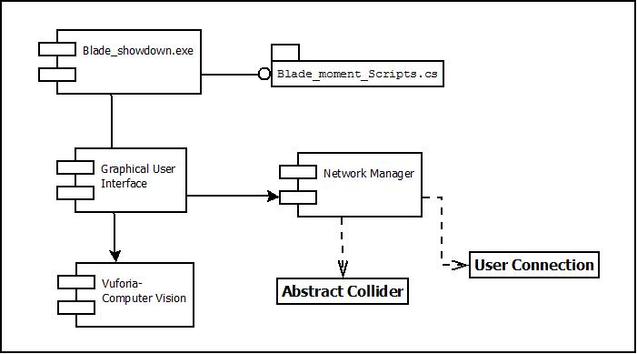

Figure 4.2.8. : Component Diagram

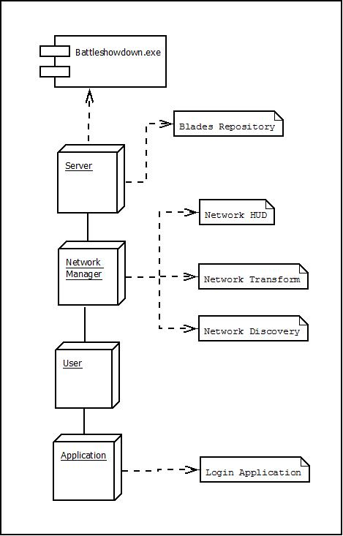4.2.9. Deployment Diagram:

Figure 4.2.9. : Deployment Diagram

# References:

1. Cynthia Allum, Elyssa Goldberg, Matthew Weinberg, Rashmi Bhagwat,”State of Augmented reality” in “Augmented Reality- a dimenaional approach”, November 2015, pp 133- 180.
2. Richard Sala & Santi Ristol, “Mobile Augmented Reality” in “The study of Google Glass” July 2012, page no.: 9- 16.
3. Ms.Akil H.Sayyad & Prof. S.A.Shinde,“ Augmented Reality Based Mobile Tour Guide System” on May 2016, section. 3, pp 279- 383.
4. October 2017. Dr Martina Reiter,” Engterprise Training with Augmented Reality”,“Reprinted in Human Computer Interaction(ICT 225) Reading and Lecture Notes, Vol1, Murdoch: Murdoch University, 2013, pp. 32- 37.